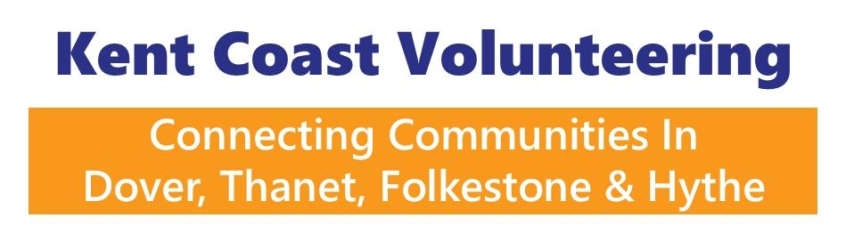

Inclusion & Accessibility Questionnaire
(For Deaf BSL/SSE Volunteers)
We want to make sure your volunteering experience is positive, inclusive, and accessible. Please complete this form so we can understand and meet your communication and accessibility needs.

1. Communication Preferences
- What is your preferred language/communication method?
  - ☐ British Sign Language (BSL)
  - ☐ Sign Supported English (SSE)
  - ☐ Written English
  - ☐ Speech/Lip-reading
  - ☐ Other: __________________________
- How would you prefer us to contact you?
  - ☐ Email
  - ☐ Text message / SMS
  - ☐ WhatsApp
  - ☐ Relay service / video relay
  - ☐ Other: __________________________

2. Meetings & Training
- Do you require a BSL interpreter for meetings/training sessions?
  - ☐ Yes, always
  - ☐ Yes, sometimes
  - ☐ No
- Do you require note-taking, captions, or other support?
  - ☐ Yes (please specify): __________________________
  - ☐ No
- Would you like information in advance of meetings (e.g. agendas, slides) to support understanding?
  - ☐ Yes
  - ☐ No

3. Environment & Accessibility
- Is there anything we should consider about the environment to make communication easier?
  - ☐ Good lighting (for lipreading/signing)
  - ☐ Quiet space (reduce background noise/visual distractions)
  - ☐ Clear seating arrangement (circle/semi-circle for visibility)
  - ☐ Other: __________________________

- Do you use any assistive technology we should be aware of?
  - ☐ Hearing aids
  - ☐ Cochlear implant
  - ☐ Live Transcribe
  - ☐ Other: __________________________

4. Emergency & Safety
- What’s the best way to alert you in an emergency?
  - ☐ Visual alarm (flashing light)
  - ☐ Tactile device (vibrating pager)
  - ☐ Text alert / phone notification
  - ☐ Tap on shoulder / physical signal
  - ☐ Other: __________________________

5. Additional Support
- Do you have any other accessibility needs we should be aware of?

- Is there anything else we can do to support you in your volunteer role?

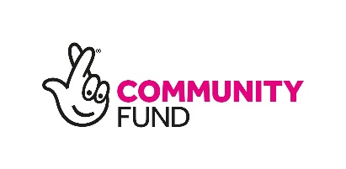
✅ Thank you for completing this form. Your answers will help us make sure your volunteering experience is welcoming, accessible, and enjoyable.

