Community Transport Service - Application Form

Please complete this form in BLOCK CAPITALS.

YOUR DETAILS
Title: ………………………… First Name: ………………………………… Surname: …………………………………………………….
Date of Birth: ……………………………………………
Address: …………………………………………………………………………………………………………………………………………………
……………………………………………………………………………………. Post Code: ………………………………………………………
Tel No.: ………………………………………………….……… Email: …………………………………………………………………………..

YOUR EMERGENCY CONTACT
Emergency Contact Name: ……………………………………………………………………………………………………………………..
Relationship to you: ……………………………………………… Tel No.: ………………………………………………………………….

YOUR HEALTH
Name of GP Surgery: ……………………………………………………………………………………………………………………………..
Can you get in and out of a car unaided? YES NO
Do you use any of the following mobility aids? Wheelchair Frame Walking Stick
Do you have a Blue Badge? YES NO
Is there anything else we should know about when providing this service to you, e.g. physical and/or mental health conditions, learning disabilities, etc.?............................................................................................................
.......................................................................................................................................................................
PAYMENT:
Our team will call you to process payment via debit or credit card upon receipt of this form.

Charity Gift Aid Declaration Form
If you are a UK taxpayer, the Gift Aid scheme will increase the value
of your donations by 25% at no additional cost to you or us!
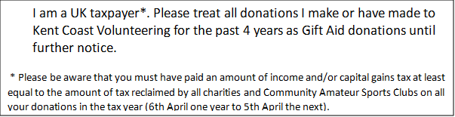

Please tick the box below to join the Gift Aid scheme.

KEEPING IN TOUCH WITH KENT COAST VOLUNTEERING (KCV)
We will keep your details on file to provide our transport service to you, but none of the information you provide will be passed to any other organisation without your permission.

AGREEMENT
I confirm I have read and understand how the Community Transport Service works. I wish to apply to join the service and agree to use it as outlined.
Signed: …………………………………………………………………………………………….. Date: …………………………………….

